USB HID Programming

Usb HID report descriptor

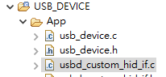

__ALIGN_BEGIN static uint8_t CUSTOM_HID_ReportDesc_FS[USBD_CUSTOM_HID_REPORT_DESC_SIZE] __ALIGN_END =

{

  /* USER CODE BEGIN 0 */

    0x05, 0x01,                    // USAGE_PAGE (Generic Desktop)

    0x09, 0x00,                    // USAGE (Undefined)

    0xa1, 0x01,                    // COLLECTION (Application)

    0x09, 0x00,                    //   USAGE (Undefined)

    0x15, 0x00,                    //   LOGICAL_MINIMUM (0)

    0x26, 0xff, 0x00,              //   LOGICAL_MAXIMUM (255)

    0x95, 0x40,                    //   REPORT_COUNT (64)

    0x75, 0x08,                    //   REPORT_SIZE (8)

    0x81, 0x02,                    //   INPUT (Data,Var,Abs)

    0x09, 0x00,                    //   USAGE (Undefined)

    0x15, 0x00,                    //   LOGICAL_MINIMUM (0)

    0x26, 0xff, 0x00,              //   LOGICAL_MAXIMUM (255)

    0x95, 0x40,                    //   REPORT_COUNT (64)

    0x75, 0x08,                    //   REPORT_SIZE (8)

    0x91, 0x02,                    //   OUTPUT (Data,Var,Abs)

  /* USER CODE END 0 */

    0xC0    /*     END_COLLECTION                */

};

Modify VID/PID

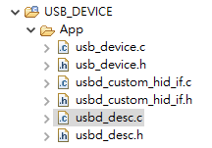

**#define** USBD_VID 1155

**#define** USBD_LANGID_STRING 1033

**#define** USBD_MANUFACTURER_STRING "STMicroelectronics"

**#define** USBD_PID_FS 22352

**#define** USBD_PRODUCT_STRING_FS "STM32 Custom Human interface"

**#define** USBD_CONFIGURATION_STRING_FS "Custom HID Config"

**#define** USBD_INTERFACE_STRING_FS "Custom HID Interface"

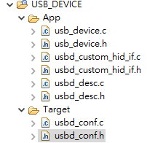

/*---------- -----------*/

**#define** USBD_MAX_NUM_INTERFACES 1U

/*---------- -----------*/

**#define** USBD_MAX_NUM_CONFIGURATION 1U

/*---------- -----------*/

**#define** USBD_MAX_STR_DESC_SIZ 512U

/*---------- -----------*/

**#define** USBD_DEBUG_LEVEL 0U

/*---------- -----------*/

**#define** USBD_LPM_ENABLED 1U

/*---------- -----------*/

**#define** USBD_SELF_POWERED 1U

/*---------- -----------*/

#define USBD_CUSTOMHID_OUTREPORT_BUF_SIZE 64U

/*---------- -----------*/

#define USBD_CUSTOM_HID_REPORT_DESC_SIZE 33U

/*---------- -----------*/

**#define** CUSTOM_HID_FS_BINTERVAL 0x5U

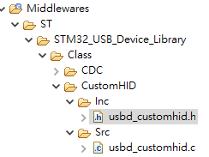

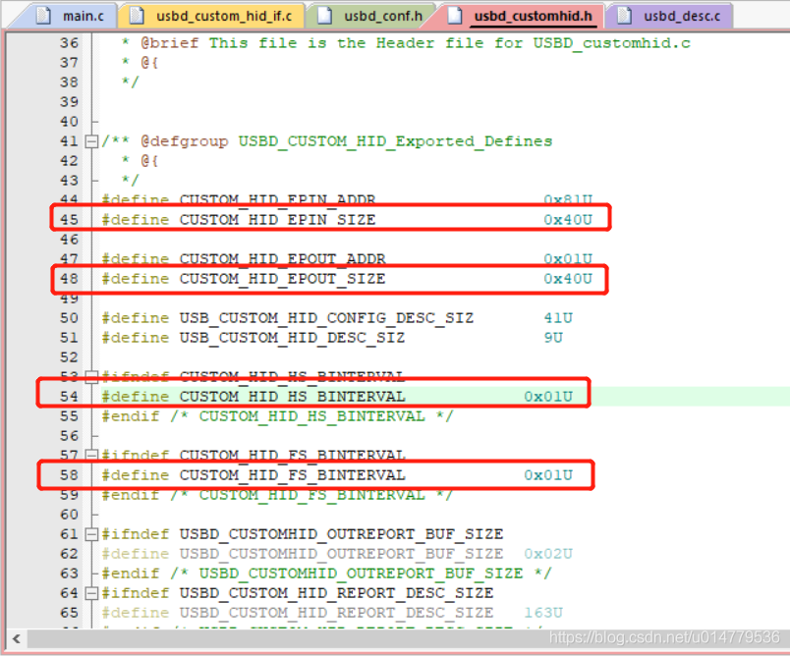

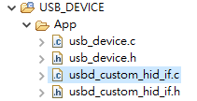

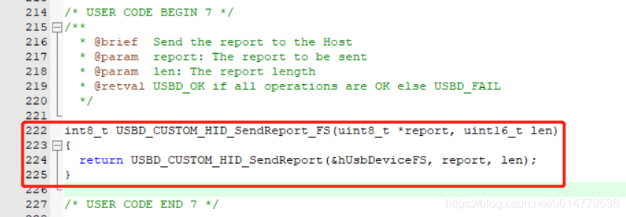

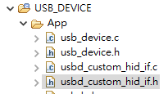

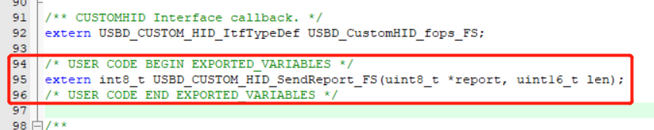

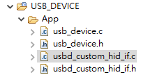

*/* USER CODE BEGIN INCLUDE */*

***#include*** *<stdbool.h>*

*/* USER CODE END INCLUDE */*

*/* USER CODE BEGIN PV */*

*/* Private variables ---------------------------------------------------------*/*

*uint8_t hid_out_report[64];*

*uint8_t hid_in_report[64];*

*bool is_hid_out_empty = true;*

*/* USER CODE END PV */*

***static*** *int8_t* ***CUSTOM_HID_OutEvent_FS****(uint8_t event_idx, uint8_t state)*

*{*

*/* USER CODE BEGIN 6 */*

*UNUSED(event_idx);*

*UNUSED(state);*

*USBD_CUSTOM_HID_HandleTypeDef *hhid =*

*(USBD_CUSTOM_HID_HandleTypeDef*) (hUsbDeviceFS.pClassData);*

***memcpy****(hid_out_report, hhid->Report_buf, 64);*

*is_hid_out_empty = false;*

*/* Start next USB packet transfer once data processing is completed */*

*USBD_CUSTOM_HID_ReceivePacket(&hUsbDeviceFS);*

***return*** *(USBD_OK);*

*/* USER CODE END 6 */*

*}*

Reference

HID

1. <http://213style.blogspot.com/2013/09/usb-human-interface-device.html>

PC

1. <https://www.codeproject.com/Articles/1244702/How-to-Communicate-with-its-USB-Devices-using-HID>

STM32

1. <https://blog.csdn.net/u014779536/article/details/104512992?utm_medium=distribute.pc_relevant_download.none-task-blog-baidujs-6.nonecase&depth_1-utm_source=distribute.pc_relevant_download.none-task-blog-baidujs-6.nonecase>
2. <https://blog.csdn.net/killf_123/article/details/107453942>
3. <https://www.twblogs.net/a/5c7124d8bd9eee68dc3f228c>
4. [HID API](https://blog.csdn.net/u010875635/article/details/73321066)
5. [USB HID and C Sharp](http://ahidlib.com/pages/programming_csharp.php?lang=en)
6. [HIDSharp](https://www.zer7.com/software/hidsharp)

aHID.dll

1. <http://ahidlib.com/pages/index.php?lang=en>
2. <http://ahidlib.com/pages/programming_csharp.php?lang=en>
3. <http://embedded24.net/>